# DFS-

Walks over all possible paths twice. Finally return to start position

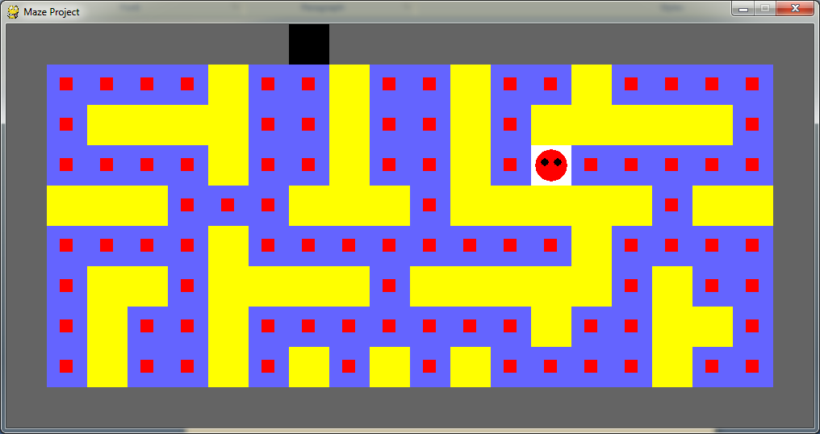

Set Path-

Scans over the map for the exit and takes first path found there. Does not always take the quickest root.

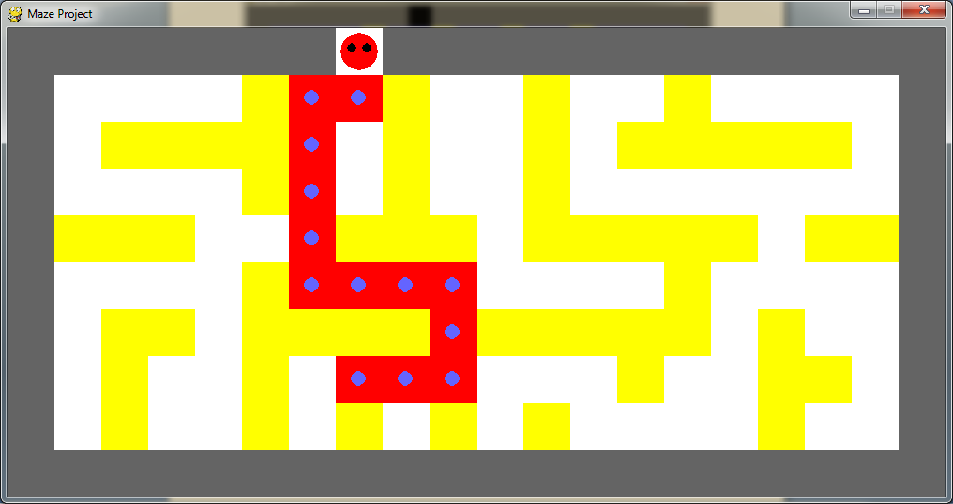

Shortest Path  
 Could not figure out, only worked when starting location is (1,6)